Catrina Hill

Exhibition Assistant Curator

Peabody Essex Museum

East India Square

Salem, MA 01970 USA

Telephone: [978-542-1614](tel:978-542-1614)

Fax: [978-744-6776](tel:978-744-6776)

Email: [catrina_hill@pem.org](mailto:catrina_hill@pem.org)

**The Harlem Renaissance Word Count 484**

The Harlem Renaissance was a flourishing of artistic, intellectual, musical and literary accomplishments by African Americans between the World Wars. The movement took its name from Harlem, a neighborhood on the northern section of Manhattan Island. Harlem became the de-facto center of the African American community in New York City, and many of the most important figures of the Renaissance called it home. During the Renaissance, intellectuals published ground-breaking work that explored philosophical questions and political possibilities for African Americans that would be explored throughout the twentieth century. Philosopher Alain Locke’s influential book *The New Negro*, published in 1925, promoted outspoken advocacy for social rights and a refusal to submit quietly to discrimination; the book was the impetus behind the “New Negro Movement,” which would eventually come to be called “The Harlem Renaissance.” One of the recurrent themes defining the Harlem Renaissance was the exploration of African culture. Black artists and thinkers were greatly inspired by Locke’s belief that African Americans should look to ancient Egyptian or sub-Saharan African traditions for inspiration; others chose to engage with ideas current in European and American Modernism.

A number of black artists came to prominence in this period. Visual artists included Aaron Douglas, Palmer Hayden, Meta Warrick Fuller, William H. Johnson, Jacob Lawrence, Archibald Motley, Jr. and Augusta Savage. Writers Langston Hughes, Zora Neale Hurston, Nella Larsen and Claude McKay all gave a literary voice to the experiences of African Americans in Harlem and around the country. Jazz music also came to national and international prominence with performers likes"Count" Basie,Duke Ellington and Billie Holiday gaining mainstream audiences and performing at the Cotton Club, then a “Whites-only” establishment. The Great Migration was a significant catalyst for the Harlem Renaissance. It is estimated that between 1910 and 1945 over a million African Americans left the South in search of a better life in Northern cities like New York, Chicago and Detroit. The Southern United States, which had a predominantly agrarian economy for centuries, had virtually failed to “reconstruct” after the Civil War. For blacks suffering under the socially entrenched racism common to the region, living conditions and employment options were often horrendous. At the same time Northern cities were growing; the industrial economy created jobs and the housing market was booming. For many blacks the North was seen as a “Promised Land” where they could build a better life. This period also saw the beginning of several important precursors of the civil rights movement including the National Association for the Advancement of Colored People (NAACP) and the National Urban League.

**References and further reading**

Ogbar, J., ed. (2010) *The Harlem Renaissance Revisited: Politics, Arts, and Letters.* Baltimore: Johns Hopkins University Press.

Thaggert, M. (2010) *Images of Black Modernism: Verbal and Visual Strategies of the Harlem Renaissance*. Amherst: University of Massachusetts Press.

Goeser, C. (2007) *Picturing the New Negro: Harlem Renaissance Print Culture and Modern Black Identity*. Lawrence: University Press of Kansas.

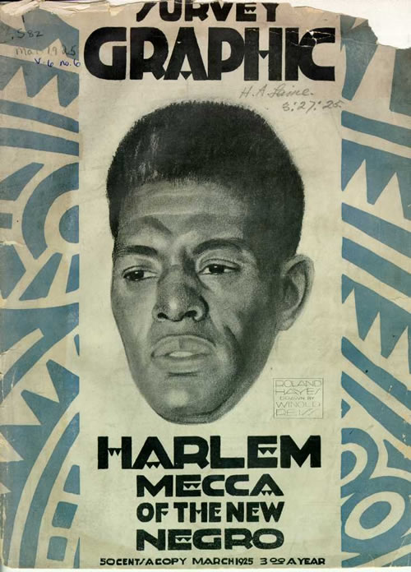

Cover of "Harlem: Mecca of the New Negro," the March 1925 issue of Survey Graphic. Courtesy of the Electronic Text Center, University of Virginia.

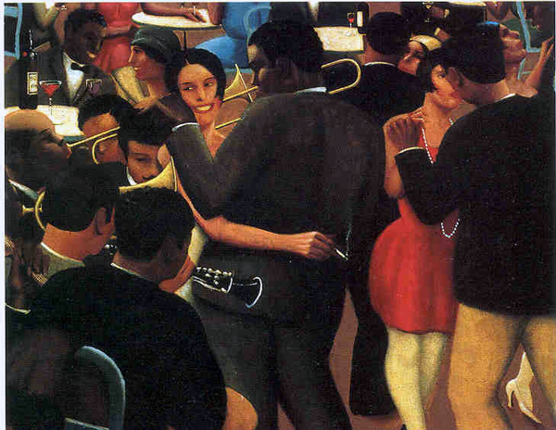

Archibald J. Motley Jr Blues, 1929

Oil on canvas

31 1/2 x 39 1/2 inches (80 x 100.3 cm)

Collection Valerie Gerrard Browne, Chicago

© Valerie Gerrard Browne (the artist’s daughter-in-law)